Home Telehealth Technical Installation Guide



November 2008
Version 1.25

Department of Veterans Affairs (VA)

Revision History
Date | Revision | Description | Author
07/27/05 | 1.0 | Initial Version | Dan Maloney
 | 1.1 | Added content | Dan Maloney
 | 1.2 | Added content | Dan Maloney
09/22/05 | 1.3 | Updated document | Dan Maloney
11/21/05 | 1.4 | Updated document | Kathleen Charters
11/29/05 | 1.5 | Added Test Patient convention | Kathleen Charters
12/14/05 | 1.6 | Incorporated feedback from Ellen Hans | Kathleen Charters
01/20/06 | 1.7 | Updated patch, added Appendices A and B | Kathleen Charters
02/02/06 | 1.8 | Changes requested by Dan Maloney: add page numbers, revise table, remove one appendix and insert content into table, correct URL. | Kathleen Charters
02/06/06 | 1.9 | Added statement regarding templates, added latest version of patch documentation to table. | Dan Maloney & Kathleen Charters
02/13/06 | 1.10 | Added TIU*1.0*200 documentation for version 12 | Kathleen Charters
03/14/06 | 1.11 | Added TIU*1.0*200 footnote for version 15. Added Troubleshooting and Resources sections. Added logical link and FileManager internal entry number troubleshooting guidance. Removed examples pending available of standardized templates. Added addendum to patch DG*5.3*644. | Carlos Borges
10/23/2006 | 1.12 | Added configuration to solve chained print problem for linked progress notes, added User Class solution to expand access to draft progress notes, local consult sub services | Dan Maloney
10/30/2006 | 1.13 | Added instructions for alternate display name for progress notes | Dan Maloney
10/31/2006 | 1.14 | Minor correction to instructions for alternate display name for progress notes | Dan Maloney
04/08/2008 | 1.15 | Updated to reflect current system | Kathleen Charters
04/16/2008 | 1.16 | Added specific instructions for configuring the VistA Hospital Location File; added instruction to remove Out of Order Message” from HT menus when authorized by Care Coordination Services | Kathleen Charters
04/29/2008 | 1.17 | Added categories of staff who may need to be involved in creation of the VistA Hospital Location for the vendor-generated Care Coordination Home Telehealth Summary of Episode Note and the Care Coordination Home Telehealth Subsequent Eval Note; corrected table stop codes according to guidance provided by Nancy Johnson of DSS | Kathleen Charters
04/30/2008 | 1.18 | Added stop code guidance provided by Nancy Johnson and Ellen Edmonson | Kathleen Charters
05/29/2008 | 1.19 | Incorporated changes recommended by Roxanne Gawronski, Rick Hines, Judy Brockert, and Phyllis Benbow; added alternative text to all images in document | Kathleen Charters
05/30/2008 | 1.20 | Added step 15, revised Appendix B, Changed Appendix C title, deleted step 14 on recommendation of Judith Siddle | Kathleen Charters
05/31/2008 | 1.21 | Changed content in the table for Consults and TIU as recommended by Roxanne Gawronski. Removed references to VistA Integration 0.9 and to the VIE where it was no longer relevant. | Kathleen Charters
06/02/2008 | 1.22 | Added qualifying statement to description of patch TIU*1.0*228 | Kathleen Charters
06/03/2008 | 1.23 | Replaced “Emerging Health Technologies” with “Office of Information and Technology” | Kathleen Charters
10/07/2008 | 1.24 | Updated facility installed components to reflect national deployment. Added troubleshooting information. Added new Appendix A TIUHL7 configuration detailed instructions and link to documentation. Reordered subsequent appendicies. | Kathleen Charters
11/21/2008 | 1.25 | Reformatted to meet National Documentation Standards. Added reference to Home Telehealth TIU Configuration document. | Kathleen Charters

Table of Contents
1. Introduction 6
1.1. Overview of Facility Installed Components 7
1.2. Instructions for VistA Configuration 9
1.3. Troubleshooting 19
1.4. Resources 20
Appendix A 22
Appendix B 24
Appendix C 26
Appendix D 29

Introduction
The goal of the Home Telehealth IT program is to integrate vendor supported Home Telehealth services into the VistA medical information infrastructure. The Home Telehealth program builds on the excellent existing and evolving VistA system. This phase of the Home Telehealth project moves us towards an integrated environment through the following process:

- The patient screening process starts with a VistA Consult.
- The Consult is completed through the standard VistA Progress Note.
- Patient sign-up is done through a VistA Patient Information Management System (PIMS) interface. The care coordinator selects the patient name, the supporting vendor, the consult type, the care coordinator’s name, and then submits the request. VistA extracts all the pertinent patient data and sends a Health Level Seven (HL7) Sign-Up message to the vendor server.
- The care coordinator then uses the vendor software to associate the home device with the patient record on the vendor system.
- Measurement data gathered by devices in the veteran’s home are stored in the vendor server and available for review, and are sent to the VA’s Health Data Repository (HDR) using HL7 messages sent through the VistA Interface Engine (VIE) Infrastructure.
- The Home Telehealth data in the HDR along with VistA data from facility VistA systems is viewed using VistAWeb, which is available through the Computerized Patient Records System (CPRS) by using the Remote Data View (RDV) function.
- Monthly, vendor servers send HL7 messages to the Sign-Up VistA facility for the Care Coordinator to review draft progress notes summarizing patient activity from the previous month.

This functionality involves components on the vendor servers as well as several VistA packages including Consults, PIMS for sign up, Progress Notes, TIU, VIE, Master Patient Index (MPI), HDR, Clinical Data Services (CDS), Clinical Context Object Workgroup (CCOW) for patient context, VistAWeb, and CPRS. Network connectivity must be available to allow these various components to operate and communicate. We have tested all these components in a network test environment called the Integrated Test Lab. However, it is very difficult to configure your facility’s test account in this networked test environment; therefore, loading VistA patches into your test account is just a test of the documentation of the package installation process.

VistAWeb, MPI, HDR, and CDS reside at the national level. The rest of the components are installed at the facility level.

Overview of Facility Installed Components
The components to be installed at the facility are distributed as VistA patches. The patches are in the VistA Patch Module in Forum.

These program components include:

Component | Description | Comments
Firewall | Change firewall rules to allow TIUHL7 messages through | Submit your system physical information to the Technology program office e-mail address (HTNetworkMonitoring@va.gov) so a CR can be submitted to allow OI&T to configure the firewall.
Consults | Patch GMRC*3.0*42, includes a standard Consult title | IRM/CAC: Patch GMRC*3.0*42 added a new service to the REQUEST SERVICES (#123.5) file in support of the Home Telehealth Project.  This patch was released Sept 2006 and should already be installed. If it is not in place, this must be installed first.
PIMS | Patch DG*5.3*644  Note: GMRC*3.0*42 must be installed before DG*5.3*644 | IRM: Configure the DGHTERR mailgroup with at least one Office of Information and Technology program office e-mail address (HTNetworkMonitoring@va.gov), one local Care Coordinator e-mail address, and one IRM/CAC e-mail address
TIU | Patch TIU*1.0*200 and TIU *1.0*228 | IRM: TIU*1.0*200 is the Generic HL7 Interface patch released Oct 2006. This patch provides a generic HL7 interface to TIU. The interface allows TIU to receive and process unsolicited HL7 messages and update existing documents or create new documents. During installation, you were prompted to install several entries into File (#8925.1) for Home Telehealth. If IRM installs and the CACs have to configure this patch, then the CACs need the TIU patch documentation. See Appendix A  TIU*1.0*228 is a TIUHL7 Generic Interface Update patch. At the current time, this patch is still in test.  Configure the mailgroup with at least one Office of Information and Technology program office e-mail address (HTNetworkMonitoring@va.gov), one local Care Coordinator e-mail address, and one IRM/CAC e-mail address.
CPRS | Configure to allow VistAWeb to be selected from the CPRS Tools menu | CAC: See Appendix B
Institution File  (File 4) | Check to ensure the Home Telehealth vendors appear in your Institution file. Their facility numbers begin with 200T. | CAC: AMD and Care Matrix do not have any VA patients. The program office uses the AMD HL7 link for testing and troubleshooting.
Hospital Location File (File 44) | Check to ensure there are hospital locations “CCHT NON VIDEO MONITOR REVIEW” and “CCHT NON VIDEO INTERVENTION” with the appropriate stop codes. | MAS ADPAC or PIMS Team or DSS Site Team: If these locations do not exist, see Appendix C for the steps to create these locations.
Out of Order Message on HT menus | Remove the “Out of order message” for HT menus. | CAC: Care Coordination Services will authorize your facility to use the HT menus. See Appendix D for the steps to make the menus functional.

Note: For each patch installed, be sure to read the directions and perform all post installation actions in the directions.

Instructions for VistA Configuration

In addition to the instructions included in the Patch descriptions, complete the following system configuration.

1. Identify Care Coordinators:
Identify the names of the Care Coordinators at your site who are involved in the Home Telehealth program. These users need VistA components added to their VistA configuration.

2. Ensure Care Coordinator access to VISTA CPRS:
Each Care Coordinator needs to have access to VistA CPRS.

3. Add HT Home Telehealth Menu:
Add the Home Telehealth Menu item (HT Home Telehealth Menu) to VistA as a standalone menu for each Care Coordinator at your facility.

4. Configure Consult Services and Consult Note Title:
The Home Telehealth business process normally begins when a clinician requests that a veteran be evaluated for Home Telehealth services by ordering a
“CARE COORDINATION HOME TELEHEALTH SCREENING” consult. This consult service was automatically created from patch GMRC*3.0*42.

Note:
- Check to make sure that the “CARE COORDINATION HOME TELEHEALTH SCREENING” Consult service is Enabled and your Update users are configured.
- Verify that the “CARE COORDINATION HOME TELEHEALTH SCREENING CONSULT” note title is ACTIVE. This consult note title was automatically created from patch TIU*1.0*200.

Configure VistA CPRS so that clinicians and Care Coordinators have access to order and sign the “Care Coordination Home Telehealth Screening” Consult.

5. Configure VistA CPRS Tools Menu:
Configure CPRS to allow users to open VistAWeb from the CPRS Tools menu (see Appendix B).

6. Configure VistA Hospital Location File (File 44):
Additions must be made to the VistA Hospital Location file to include appropriate locations with specific stop code assignments for Home Telehealth. Association of the proper Hospital Location with a Progress Note is essential for your institution to obtain Home Telehealth workload credit. The name of the clinic must be entered as CCHT NON VIDEO MONITOR REVIEW with a stop code assignment of 683 in order for the vendor generated “Care Coordination Home Telehealth Summary of Episode Note” to work correctly. In addition, another clinic must be entered as CCHT NON VIDEO INTERVENTION with a stop code assignment of 684 in order for the vendor generated “Care Coordination Home Telehealth Subsequent Eval Note” to work correctly (see Appendix C).

The Care Coordinator may have already set up appropriate locations for your institution. If not, the list below can be used as an example. (This list is from the VistA CPRS entries for Salt Lake City).

National Standard Visit Name | Primary Code | Secondary Code
CCHT Non Video Monitor Review* | 683
CCHT Non Video Intervention* | 685 | 684
Example Visit Name | Primary Code | Secondary Code
CCHT Initial Assess/Orientation/Ed | 685 | 371
CCHT Real Time Video Care | 685 | 179
CCHT Office Visit | 685
CCHT Phone Call | 686

*Highlighted entries are mandatory for the vendor-generated notes to work correctly. In the majority of cases, 685 will not be used in the primary position. Stop code 685 will only be used in the primary position when sites have CCHT programs that are a separate dedicated service that only performs CCHT (Option 1 CCS Program). In most cases, medical centers did not have the resources to have staff that only performed this activity. Instead, facilities had to add this workload to their already existing programs (Option 2 Program). This means that they use the primary stop code that represents their own program. Examples would be 323 for Primary Care, 171 for Home Based Primary Care and 318 for Geriatrics.

CCHT specific primary and secondary codes identify the workload as CCHT and the Home Telehealth program wants it identified as such to show the impact of their program on a national basis. Stop code 684 cannot be used as a primary code, it is a secondary only. Starting October 1, 2008, for FY09, stop code 371 will be a secondary only code. When the site sets-up the coding for this project, they need to follow the coding directions as previously provided to them by Care Coordination Services and DSS.

Official definition/rules prescribed by DSS for FY09 for the 683 note:

683 |  | P | CCHT NON-VIDEO MONITORING | Records workload by VA health care professionals using non-video electronic in-home messaging devices for the remote monitoring of patients on a regular basis. This code is reported once each calendar month per patient enrolled in CCHT that uses a messaging device. Not to be used to document workload for patients only using in-home video technology that does not have messaging functionality. This is a CBO count activity. For use by approved Care Coordination Home Telehealth (CCHT) Programs only.

To see the instructions that sites have to follow for national standardized coding at URL: http://vaww.dss.med.va.gov/DSS%20Documents/Conversion/FY06%20DSS%20Techinical%20Conversion%20Guidelines.doc#ch4

7. Remove Out of Order Message from HT menus
When Care Coordination Services authorizes your facility to use the HT menus, remove the Out of Order Message (see Appendix D).

8. VistA CPRS Test Patients:
It is vitally important that any test patient record that you use has a social security number (SSN) with five leading zeros (e.g., 000-00-XXXX). A patient with a SSN beginning with five zeros will not be counted in workload or included in census data. If a test patient has something other than an SSN beginning with five zeros, an inaccurate workload and census may be generated. In addition, the last name of the test patient should begin with ZZ, e.g., ZZTest.

9. Daily Monitoring of the DG HTH HL7 Server Logical Link
Check the VistA HL7 Server logical links daily to make sure that the DG HTH link remains active. This link sometimes becomes disabled or inactive. This result is a stoppage of all Home Telehealth HL7 messages moving out of and into your VistA system. This means that no patient activations or progress notes will be processed until the link is activated again and ready to send and receive Home Telehealth messages.

The Office of Information and Technology program office verifies the DGHTAMD link every 30 minutes. You may request an e-mail alert in the event the link is not available for a period (3-5 cycles). Send your request to be added to the Home Telehealth HL7 alerts mail group to HTNetworkMonitoring@va.gov.

10. Change the print name of the note title from Care Coordination Home Telehealth to CCHT
When you use the national note titles you can have an alternate title appear in your CPRS display and printouts. Below are instructions for achieving this
- Use the Document Definitions (Manager) menu – then select Edit Document Definitions option
- Expand the Progress Notes class
- Find the Care Coordination Home Telehealth Notes Document Class and expand it.
- Select Status and select I (inactivate), then select the number associated with the note title that you want to edit.
For example:
Select STATUS: (A/I/T): I INACTIVE
Selecting Entry for Status INACTIVE. Please select ONE entry. You will be prompted for another.
Select Entry: (16-29): 24

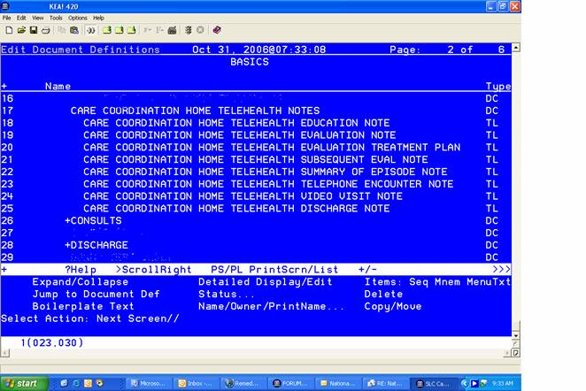

- Then select Detailed Display/Edit and the number of the note title to detail the note title that you just inactivated
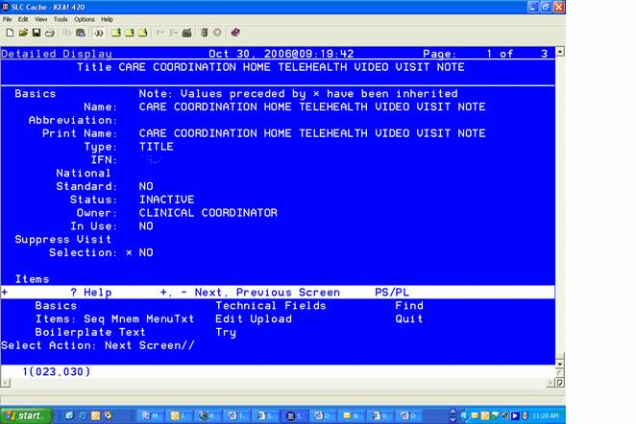

- At Select action: Type Basics
- Do NOT modify the Name
- At Print Name- you could change “Care Coordination Home Telehealth” to be CCHT. You can replace CARE...TELEHEALTH with CCHT
- Do not forget to reactivate the title when you are finished.
- Since you changed the print name, you will see CCHT instead of Care Coordination Home Telehealth as below.

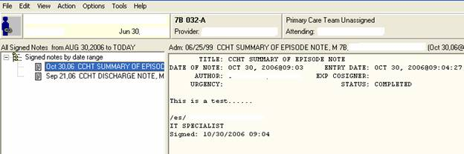

11. Configure VistA CPRS Template:
In VistA CPRS, Consult Request Service Titles and Document Titles can be set up to automatically load templates that prompt user’s data entry of specific information. These templates make data entry easier for the user and result in more complete and standardized content for the notes. National templates content has been developed by a workgroup of field staff working with Care Coordination Services. After these nationally standardized templates are completed, the field will be strongly encouraged to use them as distributed or to add to them to meet additional local requirements.

The best available templates are currently posted at URL http://vaww.va.gov/techsvc/projects/HomeTelehealth_docs.asp. This location will be updated with additional templates as they become available. Templates are distributed in the TXML format. Templates in this format can easily be imported into CPRS and made available for your use by your facility’s VistA/CPRS Clinical Application Coordinator (CAC).

Please note that the Clinical Applications Coordinator (CAC) does not need to retype the templates. They can download the .TXML file by right clicking on the template and selecting the “Save Target as” option, then select “All Files” in the box titled “Save as type:”, then press the “Save” button to save the files to their PC. Then all they need to do is import the template into CPRS and link the Template to the Note title from within CPRS using the shared templates editor.

12. Access by all facility Care Coordinators to Vendor Uploaded Draft Progress Notes
For the care coordination Home Telehealth program, there is a unique situation where each nationally contracted Home Telehealth vendor will automatically generate an unsigned draft progress note every 28 days for each enrolled veteran. This draft note is authored and sent to the attention of the one care coordinator associated with the patient record when the patient was signed up through the VistA-Home Telehealth sign up process. Until the configuration described below is implemented, no other qualified care coordinators can access the note. Without this configuration, this situation is a problem if notes arrive in VistA during the time that the designated care coordinator is not working.

In order to make Home Telehealth progress notes accessible for viewing, editing and signing, by any certified Care Coordinator at a medical center, it is necessary to create a new User Class in the Application Subscription Utility (ASU) application at each facility. It is also necessary to create three new Business Rules in ASU as well. ASU controls the way Text Integration Utility (TIU) handles the entry, viewing, editing, signing and printing of TIU documents.

A new User Class, called Home Telehealth Nurse (HT), or any other name deemed appropriate, should be created using TIU IRM MAINTENANCE MENU|User Class Management|User Class Definition. When this User Class has been created and activated, each Care Coordinator should be added as a member of the class using the List Members action.

Three Business Rules must be created using the Manage Business Rules option of the User Class Management menu. These rules are:
1 An UNSIGNED (TITLE) {title of Home Telehealth Note}
may BE VIEWED by a HT NURSE
2 An UNSIGNED (TITLE) {title of Home Telehealth Note}
may BE EDITED by a HT NURSE
3 An UNSIGNED (TITLE) {title of Home Telehealth Note}
may BE SIGNED by a HT NURSE
The rules should be written to each title used by Home Telehealth.

Once the User Class is created and populated and the Business Rules are written for each title it will be possible for any member of that User Class to access, review, edit if necessary and sign a note listing another member of the User Class as the Author. When signed, such a note will still display the original Author’s name and will display the electronic signature as signed by/for.
Example: (Taken from DAYTDEV Account)
TITLE: CARE COORDINATION HOME TELEHEALTH EVALUATION TREATMENT PL
DATE OF NOTE: MAY 16, 2006@24:00 ENTRY DATE: MAY 17,2006@16:18:05
AUTHOR: CARE COORDINATION NURSE TWO EXP COSIGNER:
URGENCY: STATUS: COMPLETED
SUBJECT: This is the subject

NEW TEST TODAY CAN CARE COORDINATION NURSE ONE SIGN THIS NOTE FOR CARE COORDINATION NURSE TWO.

/es/ CARE COORIDNATION NURSE ONE

Signed: 05/17/2006 16:20
for CARE COORDINATION NURSE TWO

These notes may be accessed via CPRS by individual patient either by a notification or by creating a custom view on the notes tab to see unsigned notes by the Author. If there are notes awaiting signature for many patients it may be more efficient to use the roll and scroll TIU options to search for unsigned notes across patients by the author. This method will display all the unsigned notes for the author in one list and they can be viewed, edited if necessary, and signed without the need to open each patient’s chart individually.

13. Local Consult Sub Services need to be added at an integrated site or alerts will be sent to all of the Care Coordinator providers in the VISN when a consult is closed.
The consult software: GMRC*3*42, creates a special consult service to be used for the purpose of receiving Home Telehealth consults. If all sites in the integrated site do not apply the modification below, all providers will receive an alert when any consult is closed, which is not useful and irritating to the clinicians.

This situation is easily remedied by using a different local consult title for each desired group, and by linking those local consult title sub services to the national title. That is, the local consults need to be made sub-services to the CARE COORDINATION HOME TELEHEALTH SCREENING consult. You also need to be sure to ENABLE the CARE COORDINATION HOME TELEHEALTH SCREENING consult; otherwise, the sub-services will not be viewable. To add as a sub-service and enable the primary consult, use the Set up Consult Services [GMRC SETUP REQUEST SERVICES] and do the following:

DAYT17>D ^XUP

Setting up programmer environment
This is a TEST account.

Terminal Type set to: C-VT102

You have 186 new messages.
Select OPTION NAME: GMRC MGR Consult Management

RPT Consult Tracking Reports
SS Set up Consult Services
SU Service User Management
CS Consult Service Tracking
RX Pharmacy TPN Consults
GU Group update of consult/procedure requests
UA Determine users' update authority
UN Determine if user is notification recipient
NR Determine notification recipients for a service
TD Test Default Reason for Request
LH List Consult Service Hierarchy
PR Setup procedures
CP Copy Prosthetics services
DS Duplicate Sub-Service
IFC IFC Management Menu
TP Print Test Page

Select Consult Management Option: SS Set up Consult Services
Select Service/Specialty: CARE ← Select the released consult
1 CARE COORDINATION HOME TELEHEALTH SCREENING DISABLED
2 CARE COORDINATION/HOME TELEHEALTH
CHOOSE 1-2: 1 CARE COORDINATION HOME TELEHEALTH SCREENING DISABLED

SERVICE NAME: CARE COORDINATION HOME TELEHEALTH SCREENING
Replace
ABBREVIATED PRINT NAME (Optional): CCHT SC//
INTERNAL NAME: CCHT SCREENING//
Select SYNONYM: CCHT SCRN//
SERVICE USAGE: DISABLED// @ ← Remove the disabled by deleting it. This will enable the consult.
SURE YOU WANT TO DELETE? Y (Yes)
SERVICE PRINTER:
NOTIFY SERVICE ON DC:
REPRINT 513 ON DC:
PREREQUISITE:
1>
PROVISIONAL DX PROMPT: OPTIONAL//
PROVISIONAL DX INPUT: LEXICON//
DEFAULT REASON FOR REQUEST:
1>Initial Screening for Home Telehealth services.
EDIT Option:
RESTRICT DEFAULT REASON EDIT: UNRESTRICTED//

Inter-facility information
IFC ROUTING SITE:
IFC REMOTE NAME:
Select IFC SENDING FACILITY:

SERVICE INDIVIDUAL TO NOTIFY:
Select SERVICE TEAM TO NOTIFY:
Select NOTIFICATION BY PT LOCATION:
PROCESS PARENTS FOR NOTIFS:
Select UPDATE USERS W/O NOTIFICATIONS:
Select UPDATE TEAMS W/O NOTIFICATIONS:
Select UPDATE USER CLASS W/O NOTIFS:
Select ADMINISTRATIVE UPDATE USER:
Select ADMINISTRATIVE UPDATE TEAM:
PROCESS PARENTS FOR UPDATES:

SPECIAL UPDATES INDIVIDUAL:
RESULT MGMT USER CLASS:
UNRESTRICTED ACCESS:
Select SUB-SERVICE/SPECIALTY: CARE ← Add your local consults here
1 CARE COORDINATION HOME TELEHEALTH SCREENING
2 CARE COORDINATION/HOME TELEHEALTH
CHOOSE 1-2: 2 CARE COORDINATION/HOME TELEHEALTH

Are you adding 'CARE COORDINATION/HOME TELEHEALTH' as
a new SUB-SERVICE (the 1ST for this REQUEST SERVICES)? No// Y (Yes)
MNEMONIC:
Select SUB-SERVICE/SPECIALTY:
SERVICE/SECTION:

Add/Edit Another Service? NO//

14. Validate Encounter Data. On signature and entry of encounter data for the vendor generated progress note an encounter will be created in PCE. To validate the encounter data, users may use any of the following PCE options:

PCE Encounter Data Entry - Supervisor [PXCE ENCOUNTER ENTRY SUPER]
PCE Encounter Data Entry [PXCE ENCOUNTER DATA ENTRY]
PCE Encounter Data Entry and Delete [PXCE ENCOUNTER ENTRY & DELETE]
PCE Encounter Data Entry without Delete [PXCE ENCOUNTER ENTRY NO DELETE]
PCE Encounter Viewer [PXCE ENCOUNTER VIEWER]

After selecting the patient or clinic, the action of LI (List by Encounter) may be selected to display encounters. The encounter and its’ status should be displayed. Additional actions may be selected to view additional information associated with the encounter.

Troubleshooting

After installing the DG patch and completing the post install instructions, check to see that the DG HTH link is active. If it is not, halt it, wait 10 minutes and start it again. This is the link that the VistA HL7 server uses, and it sometimes stops. It needs time to properly shut down before it starts up again. If you do not wait, the link may not be properly reset. In the event of an update to the DG patch, this procedure should be followed.

Check to be sure that the AUTOSTART field of the DG HTH logical link is set to “Enabled,” so that the logical link will restart after a system reboot.

If any VistA HL7 logical link inactivates, messages will back-up. A manual reset is required. IRM needs to check on the status of this link at least daily. The link should always be active. The Office of Information and Technology program office monitors the HL7 link for AMD every 30 minutes. You can request to be on the mailgroup that receives alerts when the link is not available for 3-5 cycles by sending an e-mail to HT Network Monitoring (HTNetworkMonitoring@va.gov). Check that the link is enabled for each vendor: DG HT ATI, DG HT HH, DG HT VN, DG HT VIT, DG HT A AMD (monitored by the program office).

The Network Monitor (http://vaww.etech.med.va.gov/networkstatus/) tracks the status of your system. If an error response from VistA Messaging (see HL7 message below) indicates that VistA Messaging cannot find your TIU application (TIUHL7), check the configuration **

MSH^~|\&^TIUHL7^509~HL7.FACILITY.MED.VA.GOV~DNS^HTAPPL^200T2~VAWW.HL7.AMDTELEMED.CC.MED.VA.GOV~DNS^20080925113105-0500^^ACK^509832040312^P^2.4 MSA^CR^ FACILITY20080925113048^Invalid Receiving Application

If VistA cannot accept progress notes after installing Patch TIU*1.0*200, then try removing all settings and re-entering them to force congruence in the internal entry number

Report all technical issues that cannot be resolved by your local IRM support team to the VA National Helpdesk, including problems encountered during the testing process. For all technical issues resolved by your local IRM support team, please e-mail a description of the problem and the solution to the Shared Mailbox: VHA CO 11CC shared mailbox. Clinical issues may also be reported to VHA CO 11CC shared mailbox.

A weekly call is held on Tuesday at 10:00 a.m. EST for all activation sites and developers (1-800-767-1750, access code 57529#). Additional calls will be scheduled as needed.

Resources

Additional project information is available on the VHA Home Telehealth project Web site: http://vaww.va.gov/techsvc/projects/HomeTelehealth.asp

Glossary
Term | Definition
ACK | A general acknowledgment message (ACK) used to respond to a message where there has been an error that precludes application processing or where the application does not define a special message type for the response.
Acknowledgment - Application Level | The appropriate application on the receiving system receives the transaction and processes it successfully. The receiving system returns an application-dependent response to the initiator.
Acknowledgment - Accept Level | The receiving system commits the message to safe storage in a manner that releases the sending system from any obligation to resend the message. A response is returned to the initiator indicating successful receipt and secure storage of the information.
Austin Information Technology Center (AITC) | Austin Information Technology Center (AITC) is a corporate data center for VA. The central repository for National Patient Care Database is maintained at the AAC.
Care Coordinators | Care Coordinators are licensed health care professionals who help veteran patients self-manage their condition. Care Coordinators guide and support veteran patients to ensure they receive the right care, in the right place, at the right time, from the right person.
Clinical Data Services (CDS) | Clinical Data Service (CDS) is the access service to patient-centric, clinical data persisted in HDR (Health Data Repository) data stores.
Clinical Context Object Workgroup (CCOW) | Clinical Context Object Workgroup (CCOW) is used to share patient and user context between applications
Consult | Referral of a patient by a healthcare provider to another hospital service/specialty, to obtain a medical opinion based on patient evaluation and completion of any procedures, modalities, or treatments the consulting specialist deems necessary to render a medical opinion.
Computerized Patient Records System (CPRS) | Computerized Patient Records System (CPRS) provides an integrated patient record system for clinicians, managers, quality assurance staff, and researchers. The primary goal of CPRS is to create a fast and easy-to-use product that gives physicians enough information through clinical reminders, results reporting, and expert system feedback to make better decisions regarding orders and treatment. VistA software integrated with CPRS includes Pharmacy, Lab, Radiology, Allergy Tracking, Consults, Dietetics, Progress Notes, Problem List, Patient Administration, Vitals, PCE, TIU, ASU and Clinical Lexicon.
Data File Number (DFN) | Patient’s Internal Entry Number (IEN)
Health Data Repository (HDR) | A data repository of clinical information that resides on one or more independent platforms and is used by clinicians and other personnel to facilitate longitudinal patient-centric care.
Health Level 7 (HL7) | HL7 is an ANSI standard for electronic data exchange in healthcare environments. It is an interface specification designed to standardize the transfer of health care information between systems. HL7 is an application layer protocol for electronic data exchange in health care environments. The HL7 protocol is a collection of standard formats for health care data. This communication protocol allows healthcare institutions to exchange key sets of data between different application systems. The protocol accommodates the flexibility necessary to allow compatibility for specialized data sets that have facility-specific needs.
ID | Coded Value data type
Interface Engine (IE) | A device or software application that connects disparate system, transforms data, converts data, routes data, ensures the delivery of data and is rules based. The IE provides a consistent HL7 compliant communication environment. That is separate from the specific and individual application needs. In this environment, messages can be routed, transformed, converted and delivery guaranteed as required by the application.
Integration Control Number (ICN) | The Integration Control Number (ICN) is a unique identifier assigned to patients when they are added to the Master Patient Index (MPI). ICNs fall under two categories: national and local. The ICN follows the ASTM E1714-95 standard for a universal health identifier. ICNs link patients to their records across VA systems.  The ICN is stored in a message using the HL7 CX format.  The ID subfield is the ICN.  The type subfield is USVHA.
Master Patient Index (MPI) | The objectives of the Master Patient Index (MPI) are to create an index that uniquely identifies each active patient treated by the VA and to identify the sites where a patient is receiving care. This is crucial to the sharing of patient information across sites.  MPI manages the synchronization of patient file information between the Master Patient Index and the patient's treatment facilities to ensure that data being shared is stored in the correct patient's record.
Patient Information Management System (PIMS) | Contains patient information
Protocol | A set of procedures for establishing and controlling data transmission
Remote Data View (RDV) | A CPRS application that allows a caregiver to view patient data that is stored in another VistA facility.
Telehealth | Telehealth is the use of electronic communications and information technology to provide and support health care when distance separates the participants. It covers health care practitioners interacting with patients and patients interacting with other patients.
Telemedicine | Telemedicine is the provision of care by a licensed independent health care provider that directs, diagnoses, or otherwise provides clinical treatment delivered using electronic communications and information technology when distance separates the provider and the patient. .
TCP/IP | Transaction Control Protocol/Internet Protocol (TCP/IP) is a set of protocols for Layers 3 (Network) and 4 (Transport) of the OSI network model. TCP/IP has been developed over a period of 30 years under the auspices of the Department of Defense. It is a de facto standard, particularly as higher-level layers over Ethernet. TCP/IP predates the OSI model; therefore, TCP/IP is not OSI-compliant.
VistA | Veterans Health Information Systems and Technology Architecture (VistA), formerly known as Decentralized Hospital Computer Program (DHCP), encompasses the complete information environment at VA medical facilities. It consists of hardware, software packages, and comprehensive support for system-wide and station specific, clinical, and administrative automation needs.
VistA Interface Engine (VIE) | Vitria BusinessWare software that has been configured specifically for the VHA VistA environment
VistA Web | A web based application to view patient data from various VA facilities.

Appendix A

TIUHL7 documentation is available at http://www.va.gov/vdl/documents/Clinical/CPRS-Text_Integration_Utility_(TIU)/tiuhl7.pdf. Pages 6-9 describe the configuration process. This information is also available in the Home Telehealth TIU Configuration document available at http://vaww.va.gov/techsvc/projects/eHomeCare/HomeTelehealthTIUConfiguration.doc
Once your TIU application is properly configured and the firewall rules are enabled, the Care Coordination team can sign up a test patient with the Home Telehealth CCS designated vendor.

Appendix B
Configuration of CPRS for launching VistAWeb from the CPRS Toolbar

Here is an example of how to configure CPRS so users can launch VistAWeb from the CPRS Toolbar. Sign on to VistA in programmers’ mode:

Select GUI Parameters Option: TM GUI Tool Menu Items

CPRS GUI Tools Menu may be set for the following:

1 User USR [choose from NEW PERSON]
2 Location LOC [choose from HOSPITAL LOCATION]
2.5 Service SRV [choose from SERVICE/SECTION]
3 Division DIV [choose from INSTITUTION]
4 System SYS [YOUR SITE.MED.VA.GOV]
9 Package PKG [ORDER ENTRY/RESULTS REPORTING]

Enter selection: 4 System YOUR SITE.MED.VA.GOV

------ Setting CPRS GUI Tools Menu for System: YOUR SITE.MED.VA.GOV

Sequence: 11// << your sequence number may be different
Name=Command: &VistaWeb="https://vistaweb.med.va.gov/toolspage.aspx?q9gtw0=###&xqi4z=%DFN&yiicf=%DUZ"

Note: ### refers to your sites’ station number

Name=Command: &VistaWeb="https://vistaweb.med.va.gov/toolspage.aspx?q9gtw0=552&xqi4z=%DFN&yiicf=%DUZ"
Replace
Select Sequence:

Appendix C
Hospital Location Setup
The person who creates hospital location varies by facility. Adding a hospital location may be done by the MAS ADPAC or PIMS Team or DSS Site Team.

In order to capture workload for Home Telehealth, two new clinics must be established using the Set Up a Clinic [SDBUILD] option. It is not necessary to set up availability as no appointments will be scheduled to these clinics. Many of the prompts should be answered according to hospital policy. If no configuration is necessary, select “Return.” It is required that the prompts shown below be answered as follows:

Select CLINIC NAME: CCHT NON VIDEO MONITOR REVIEW
Are you adding 'CCHT NON VIDEO MONITOR REVIEW' as
a new HOSPITAL LOCATION? No//Y (Yes)

SERVICE: MEDICINE

NON-COUNT CLINIC? (Y OR N): NO

STOP CODE NUMBER: 683 NON-VIDEO MONITORING ONLY 683

WORKLOAD VALIDATION AT CHK OUT: Y YES

SCHEDULE ON HOLIDAYS?: Y YES

Below is an example of the clinic setup:

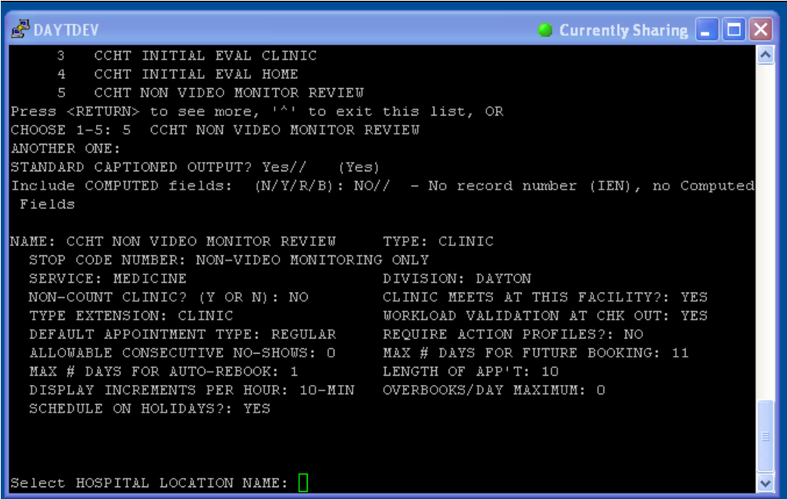

The second clinic must be set up in the same manner as described above, however, the name of the second clinic should be CCHT NON VIDEO INTERVENTION and the stop code assignment should be 684.

Appendix D
Removing Out of Order Message from Home Telehealth Menus

All HT menu options are installed set to OUT OF ORDER. The following is an example of removing the OUT OF ORDER from one menu option. See patch DG*5.3*644 for the complete list of options. This process must be completed for each menu option in order for the Care Coordinators to use VistA Integration.

WAS>D P^DII

VA FileMan 22.0

Select OPTION: 1 ENTER OR EDIT FILE ENTRIES

INPUT TO WHAT FILE: OPTION//
EDIT WHICH FIELD: ALL//

Select OPTION NAME: DGHT
1 DGHT HL7 MESSAGE MONITOR Home Telehealth HL7 Message Monitor
2 DGHT HOME TELEHEALTH Home Telehealth Menu

CHOOSE 1-5: 2 DGHT HOME TELEHEALTH Home Telehealth Menu
NAME: DGHT HOME TELEHEALTH Replace
MENU TEXT: Home Telehealth Menu Replace
OUT OF ORDER MESSAGE: Activation of option requires Care Coordination Services approval. ←---- Delete this to activate option.
LOCK:
REVERSE/NEGATIVE LOCK:
DESCRIPTION:
This option is used to sign-up and deactivate eligible patients for Home Telehealth care provided by a vendor. This option is also used to generate HL7 messages to send to the appropriate Home Telehealth vendor server system via the Austin Interface Engine.

Edit? NO//
HELP FRAME:
PRIORITY:
PROHIBITED TIMES:
Select TIMES PROHIBITED:
Select TIME PERIOD:
RESTRICT DEVICES?:
Select PERMITTED DEVICE:
TYPE: menu//
Select ITEM: DGHT TRANSMISSION REPORT//
ITEM: DGHT TRANSMISSION REPORT//
SYNONYM: TR//
DISPLAY ORDER: 40//
Select ITEM:

Reuse of internal entry numbers is a known glitch in Fileman.

